**IMT 562 Assignment 3: Makeover Monday**

**Dataset**: Railroad Infrastructure Quality and Rankings

Link: <https://data.world/makeovermonday/2022w47>

This dataset contains information of railway road infrastructure quality and global ranking of different countries over a span of 10 years (2009-2019). This was a relatively large dataset with 1257 rows and 5 columns namely:

1. Countries
2. Railroad infrastructure quality
3. Global ranking
4. Available data
5. Year

The column ‘Available data’ seemed quite irrelevant as it was the same for all rows (i.e 2009-2019)

**Original Visualization**

The original visualization was a bar chart displaying the railroad infrastructure quality of different countries for the year 2019. This bar chart had been sorted in descending order based on the railroad infrastructure quality value.

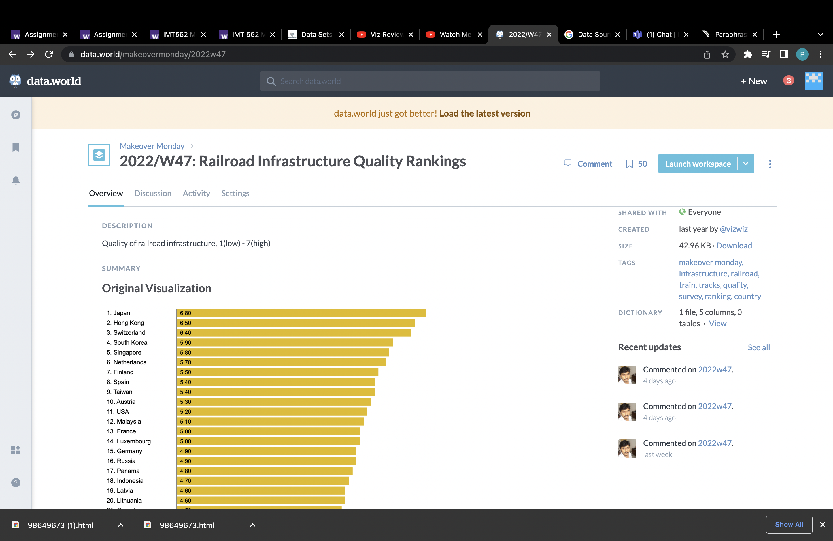

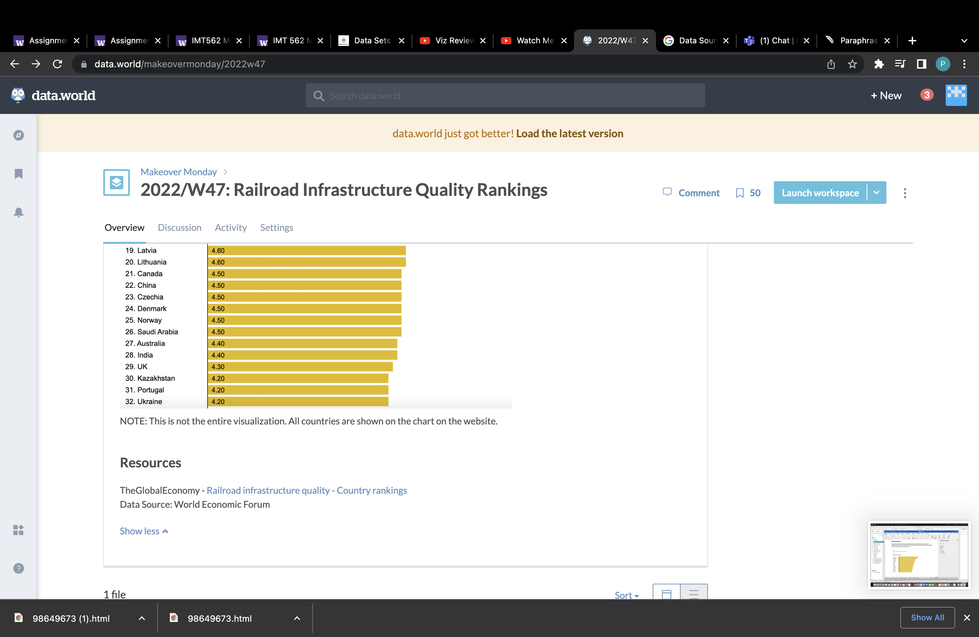

**Evaluation of the original visualization:**

Positives:

1. Simplicity: This chart is very straightforward and simple to comprehend. The fact that it has been sorted not only makes it more readable but also makes the chart look cleaner.
2. Sorting: The chart is arranged in descending order depending on the value of railroad infrastructure quality. This is highly useful for times when we are just interested in the top or bottom n data. Additionally, sorting makes the chart appear crisp and clean.
3. Labelling: The alignment of labels chosen makes the chart look consistent and organized. Right/Centre alignment of labels would have been messy due to varying lengths of the bar.

Negatives (Prioritized):

1. This chart displays data of only one year. This essentially means that more than half of the information has not been conveyed. The dataset is huge and holds a lot more information than what is being portrayed in this chart. The dataset is massive and contains far more information than what is seen in this figure. To make the chart more effective and insightful, an interactive component should have been introduced. **(P1)**
2. It is cumbersome to have to scroll down every time we need to establish a country's railroad infrastructure quality. **(P1)**
3. Given that we are talking about locations, a map would have been a more appropriate visualization chart. **(P1)**
4. The chart does not show how quality of railway road has changed over time in each country. **(P1)**
5. The description of the chart mentions "Quality of railroad 1(low) - 7(high)". It would've been more insightful if the bars were colored according to the category (high or low) of quality the country belongs to. (**P2)**
6. Forecast can be used to predict the global ranking and the quality of railway road of countries. **(P3)**

**Questions Based on Evaluation of Original Visualization:**

1. Will making the visualization interactive enable us to convey more information?
2. Does the use of filters and parameters help with creating cleaner charts?
3. Does representation of data on map improve the interpretability of the chart?

**Modified Visualization:**

Two visualizations were generated with the aim of conveying maximum information

*Viz I (Top):*

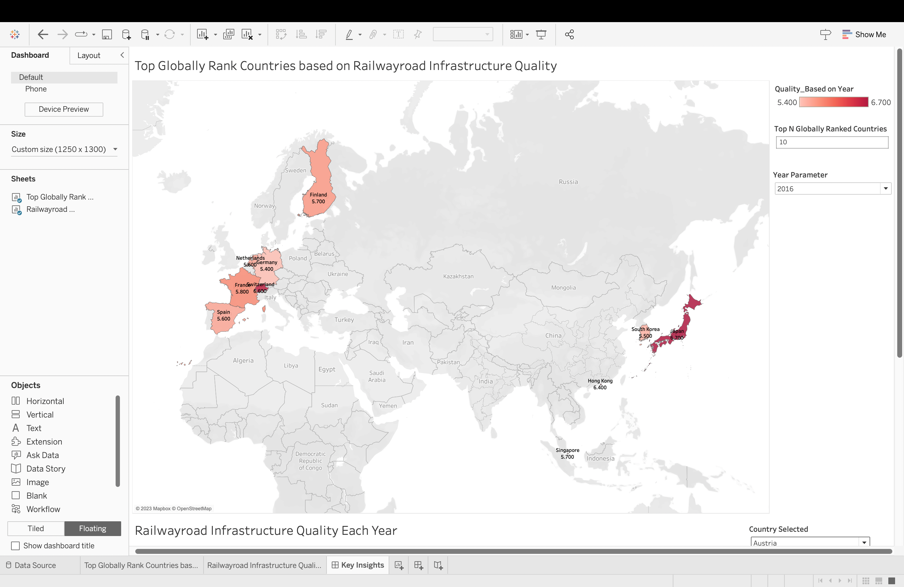

**Note: This is just a screenshot of the visualization. The interactive dashboard has been uploaded separately and twbx file.**

Design Choice and Implementation:

As discussed previously, since locations are involved, Map chart seemed like the most suitable choice. The aim of this visualization was to highlight top N globally ranked countries for a chosen year. To achieve this, I have created two parameters as follows:

1. Year Parameter: I have created a parameter for selecting the year. This parameter is used to limit the data to the year specified.
2. Top N Globally Ranked Countries Parameter: This parameter is used to choose a 'n' number of countries with the greatest 'n' values for railroad infrastructure quality. I have created a set with the following condition.

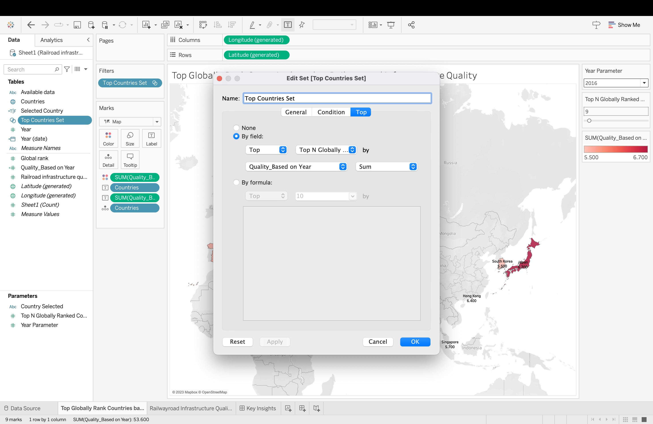

The intensity (darkness) of the color is varying based on the railroad infrastructure quality value. The darker the color fill in that country, the better is the railroad infrastructure quality.

The country name along with their railroad infrastructure quality value have been labeled on the map chart to make it more informative and interpretable. Furthermore, few countries (such as Hong Kong) were unrecognizable on the map as they appeared to be very tiny. Some of these countries were highly ranked and couldn’t be ignored. As a result, I decided to label the chart in order to draw attention to these countries.

*Viz II (Bottom):*

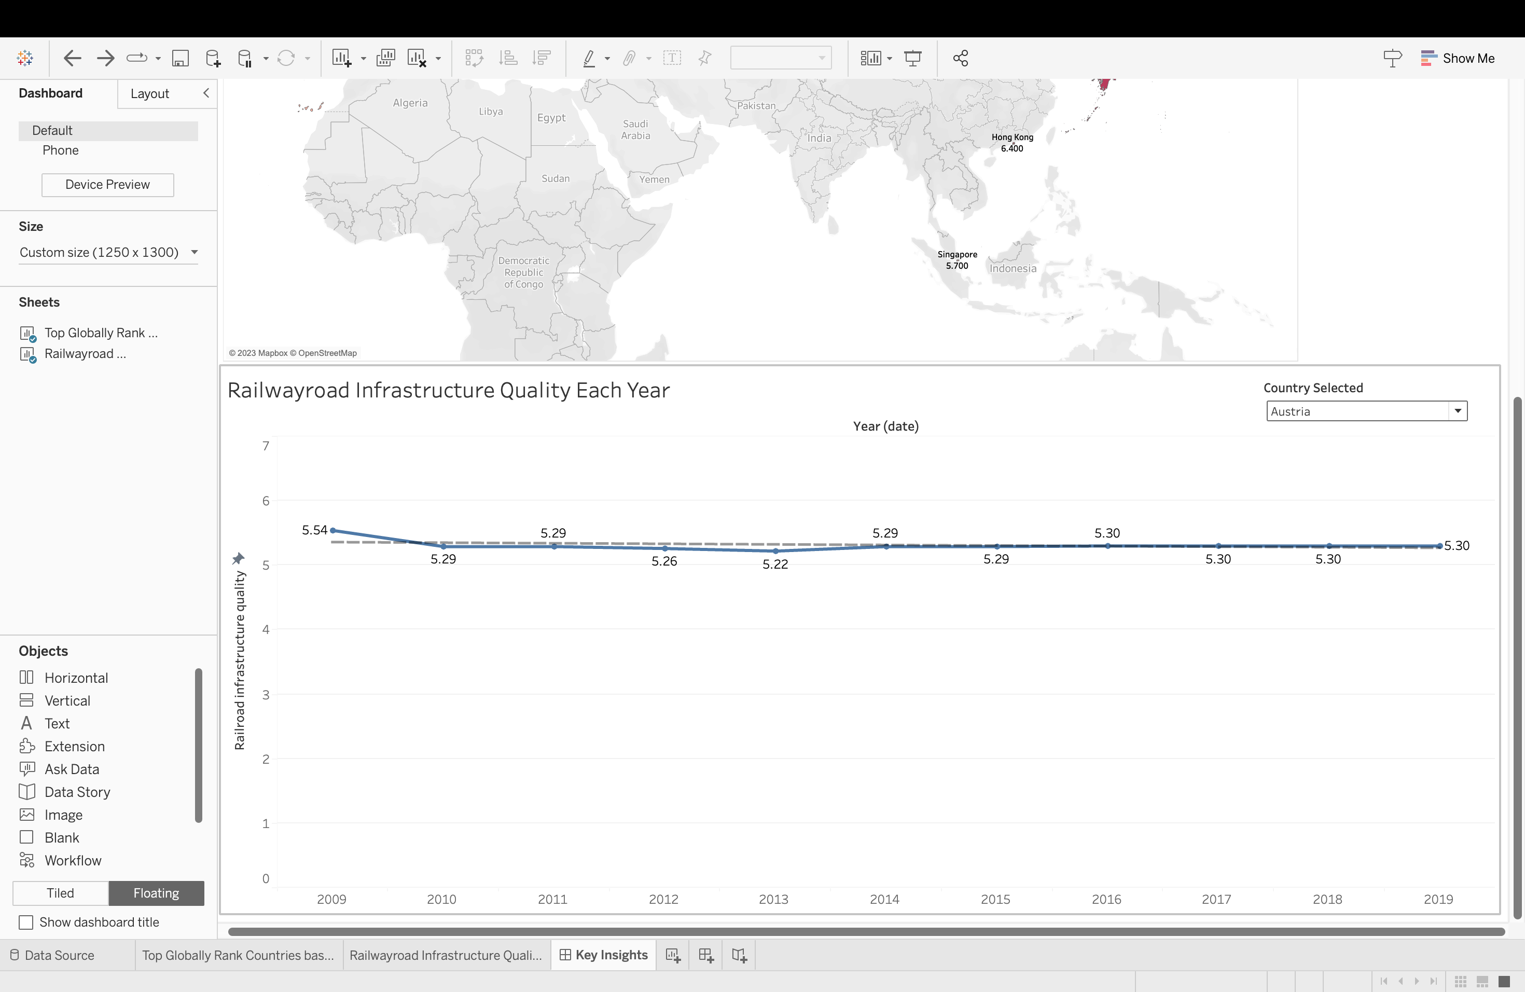

**Note: This is just a screenshot of the visualization. The interactive dashboard has been uploaded separately and twbx file.**

Design Choice and Implementation:

While generating this visualization, my primary emphasis was on the question “how quality of railway road infrastructure has varied with time for a particular country”. For this I have implemented a time series. Plotting data for all countries (bump chart), would have made the graph confusing and incomprehensible. To prevent this cluster, I added a parameter to the chart enabling the user to view data of one country at a time. Along with this, a trend line has been implemented to illustrate the relationship between quality and time.

Both charts below display the same information but with different axis. However, the drop in quality appears to be much bigger in the above chart as compared to that in the below chart due to different axis. This was problematic in my chart because as the country selection was changing, the axis was changing, making it difficult to compare the data of countries. Thus, the y-axis, which was initially ‘automatic’, was altered to be ‘fixed’ to avoid visually misleading insights.

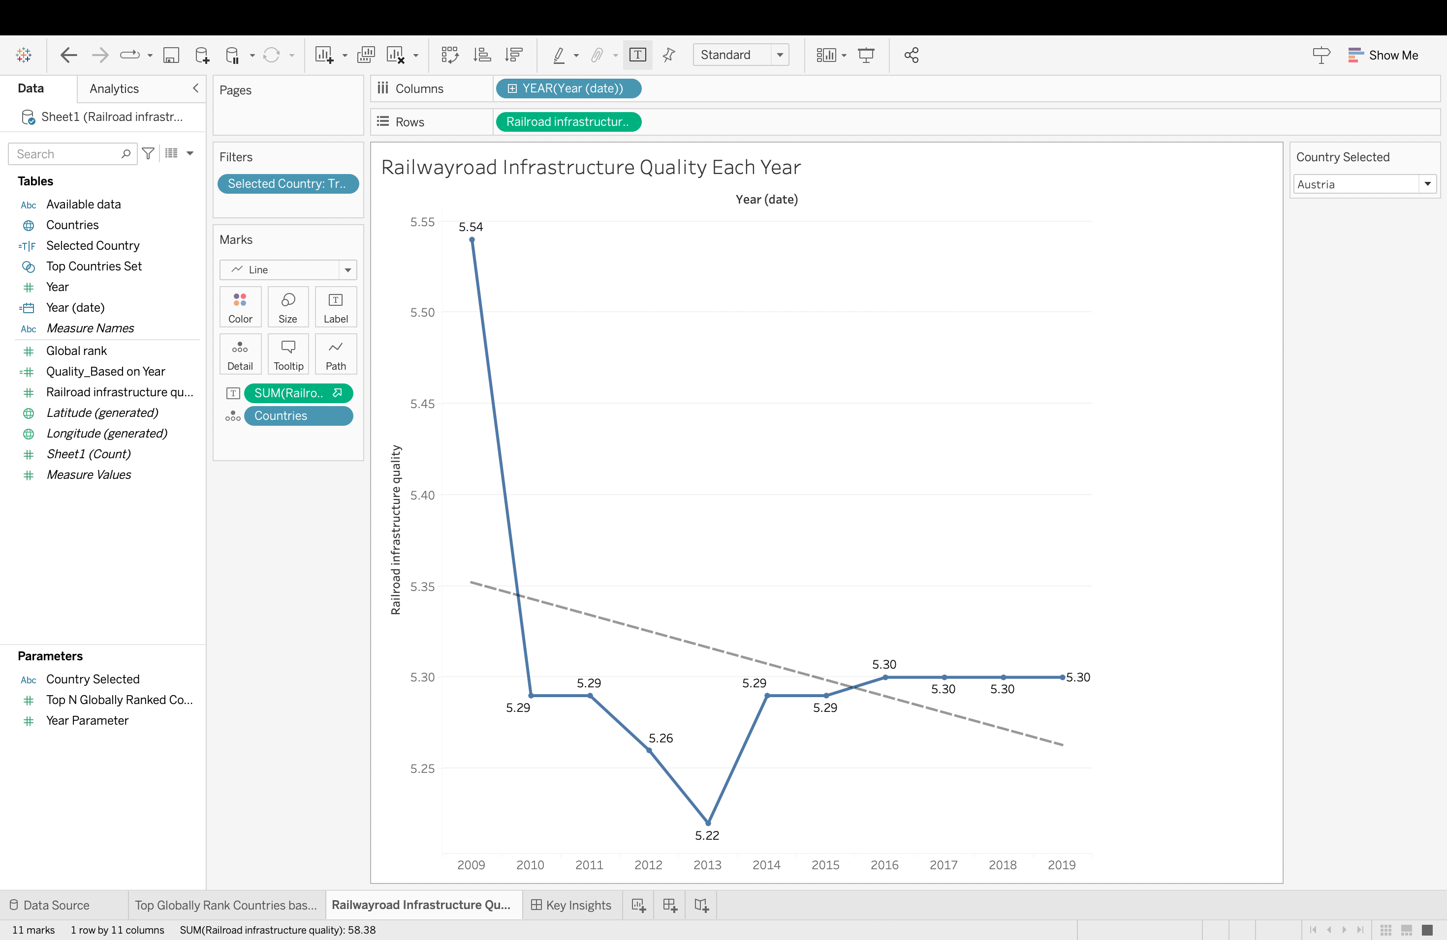

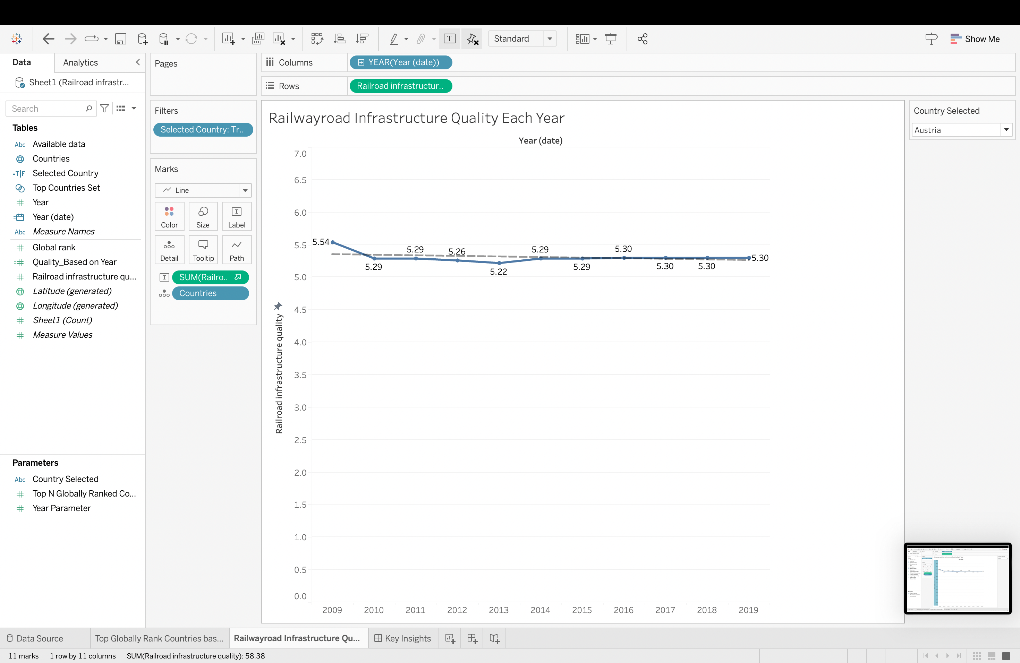

The modified visualization is more insightful and interpretable. The use of filters and parameters has ensured the charts neatness despite the myriad amount of data.

**Key Insights:**

With the modified dashboard, we can get answers to the following questions:

1. Which are top globally ranked countries in each year? Are there any countries that have remained in the top in all 10 years (2009-2019)
2. How has the quality of railway road infrastructure varied with time for each country? Has the overall quality increased/decreased/remained constant with time?

One potential application for this dataset would be to anticipate the rank and quality based on prior year data using forecast, which is presently not possible owing to missing data.